Methods to analyze research stimulation experiments

AJorge March 2019

Trial = one stimulation (single 1 second trial while stimulating at 1 Hz in one tract)

Set = usually 30 stimulations (each set is associated with a tract (medial, posterior, central))

**Get raw data to processed data (pro)**

1. Run SCRIPT_researchStim_preprocessing.m
   1. Load 1kHz data
   2. Mark stimulation times (to know rough time markers)
   3. Load 30kHz data (only selected times from above)
   4. Mark stimulation times (more precise)
   5. Save each set/trial with 30kHz

**pro structure (one per set):**

hdr: [1×1 struct]

label: {192×1 cell}

time: {1×30 cell}

trial: {1×30 cell}

fsample: 30000

sampleinfo: [30×2 double]

trialinfo: [30×1 double]

cfg: [1×1 struct]

**Get pro data (30 trials per channel) into average data (1 average trial per channel)**

1. SCRIPT_pro_to_avg_basestat.m
   1. Load one set (do baseline set first, then do actual stim setts)
   2. Detrend the processed data raw
   3. Smooth
   4. Average
   5. Save as one avg.trial

**avg structure (all patients, all electrodes, all sets):**

data: {1×2080 cell} averaged voltage signal

time: {1×2080 cell} time for data (ms)

tstat_sett: {1×2080 cell} the t-stat for the actual stim sett

tstatb_975: {1×2080 cell} the baseline t-stat 97.5th quantile

tstatb_025: {1×2080 cell} the baseline t-stat 02.5th quantile

channel: {1×2080 cell} channel name (e.g. ecog_101)

electrode_n: [1×2080 double] channel number

sett: [1×2080 double] set (e.g. 1=medial, 2=posterior, 25=baseline)

pt: [1×2080 double] DBS3005

brodmann: [1×2080 double] which brodmann area is the contact?

sett_was_chosen: [1×2080 double] 1 or 0 if the tract was the chosen for implant

Get peaks from avg

Only count significant peaks (i.e. avg.tstat_sett (@peakpoint) > avg.tstatb_0975) otherwise is NaN

**Peaks structure (all patients, all electrodes, all sets)**

EP1v[1x2080]

EP1t

EP2v

EP2t

EP3v

EP3t

channel: {1×2080 cell} channel name (e.g. ecog_101)

electrode_n: [1×2080 double] channel number

sett: [1×2080 double] set (e.g. 1=medial, 2=posterior, 25=baseline)

pt: [1×2080 double] DBS3005

brodmann: [1×2080 double] which brodmann area is the contact?

sett_was_chosen: [1×2080 double] 1 or 0 if the tract was the chosen for implant

Appendix A

Why do we need to detrend?

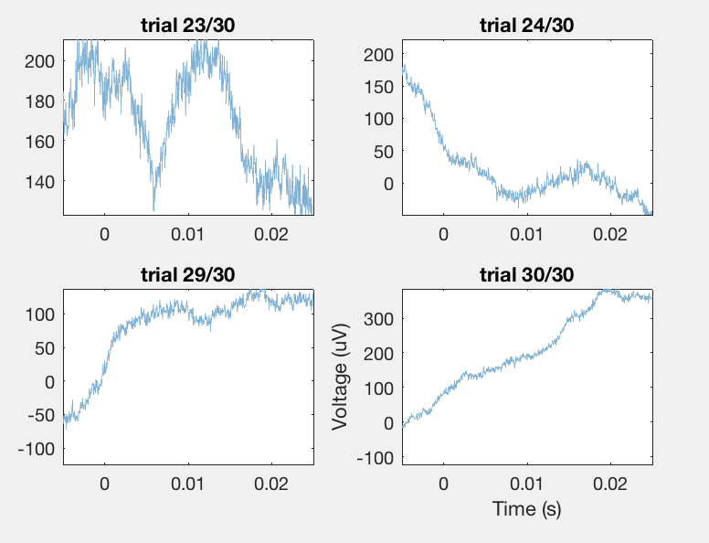 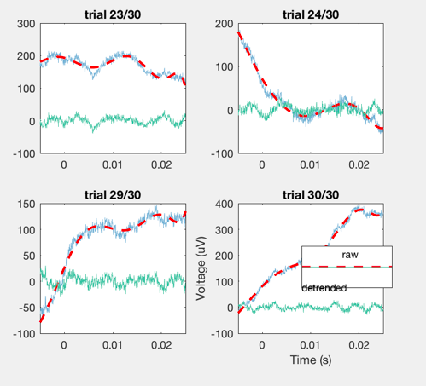 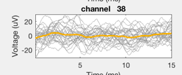

Figure. (a) appearance of the raw baseline in blue. There are low frequency oscillations that we need to detrend (we could use a high pass filter, but this wouldn’t work for the stimulation trials). To keep it consistent, we detrend the baseline (red detrend) in the same way we detrend the trials. (b) the green trace shows the results of detrending. (c) averaged all trials (gray) into one average trace (yellow).